PEOPLE'S COMMITTEE OF HO CHI MINH CITY
SAIGON UNIVERSITY
FACULTY OF INFORMATION TECHNOLOGY



PROJECT:
TESTING A COMPUTER SALES WEBSITE

Group member : 3122411110 – Nguyen Huynh Truc Lam
3122411233 – Huynh Le Hoang Tuan 3122411008- Nguyen Duc Hoang Anh Lecturer: Do Nhu Tai

Ho Chi Minh City ,November 2025
Contents
Foreword 1
Chapter 1. Topic overview 2
1.1. Introduction to the topic 2
1.2. Technology used 2
1.3.User Requirements 3
1.3.1. Functional requirements 3
1.3.2. Non-functional requirements 3
1.4. Project implementation plan 3
Chapter 2. Software Design Analysis 4
2.1. System Design Analysis 4
2.1.1. Business context 4
2.1.2. Business process 4
2.1.3. Conceptual model 6
2.2. General functions 9
2.2.1. Agents in the system and general functions 9
2.2.2.Context Diagram 11
2.2.3.Use case 11
2.2.4.User stories 13
2.3. Data Design 15
2.3.1. Concept-level database schema 15
2.3.2. Logic-level database schema 16
2.4. System design 18
2.4.1. System architecture 18
2.4.2.Domain Driven Design (DDD) 19
2.4.3. Data Models 20
2.4.4. Interface 21
2.5. Architectural design 28
2.5.1. Block Diagram 28
2.5.2. C4 architecture 28
2.5.3. Implementation diagram 32
Chapter 3: Test Plan 33
3.1.Introduction 33
3.1.1. Purpose 33
3.1.1. Scope 33
3.2. Items to be tested 33
3.2.1. Functions 33
3.2.2. Usability 35
3.2.3. Compatibility 36
3.2.4. Interface 36
3.2.5. Security 36
3.2.6. Databases 37
3.2.7. Performance 37
3.2.8. Crowds 37
3.2.9. Regression 37
3.2.10.API 38
3.3. Untested items 38
3.3.1. Functions of the Triple Test Side System 38
3.3.2. Advanced Security Testing 38
3.3.3. Advanced usability testing 39
3.4. Criteria for acceptance testing 39
3.4.1. Test coverage 39
3.4.2. Percentage of test cases passed 39
3.4.3. Number of Test Cases 39
3.4.4. Number of errors 40
3.4.5. Unit Test Density 40
3.4.6. Source code coverage 40
3.4.7. CI/CD process 40
3.5. Testing strategy 40
3.5.1. Testing methods 40
3.5.2. Type of test 41
3.5.3. Test level 44
3.6. Resources 46
3.6.1. Human resources 46
3.7. Environment 47
3.7.1. Hardware 47
3.7.2. Software 47
3.7.3. Infrastructure 48
3.8. Documents handed over 48
Chapter 4. Test design 49
4.1.Introduction 49
4.2. Design and testing process according to V-model 49
4.2.1.Requirements Analysis – 1a 49
4.2.2. System design – 2a 50
4.2.3. Architectural design – 3a 50
4.2.4. Module design – 4a 50
4.2.5. Unit Testing – 1b 51
4.2.6. Integration Testing – 2b 51
4.2.7. System Testing – 3b 52
4.2.8. Acceptance Testing – 4b 52
4.3. Design and test techniques 53
4.3.1. Black box testing 53
4.3.2.White Box Testing 54
4.4. Testing methods 54
4.4.1. Manual testing 54
4.4.2. Automated testing 55
Chapter 5. Test Report 56
5.1.Overview of the testing process 56
5.2. Test case reports 56
5.2.1. Introduction 56
5.2.2. Coverage 57
5.2.3. Execution Results 58
5.3.Bug reporting 58
5.3.1. Classification of faults by severity 58
5.3.2. Error statistics 58
5.3.3. Error handling process 59

Prologue
With the remarkable development of information technology today, the Internet has become essential to life in all fields of science and technology. This is thanks to the development of website systems, making websites play an extremely important role for us, from entertainment to commerce.
With the internet, we can perform many tasks simultaneously at a faster speed and at a lower cost compared to traditional methods. This is why the development of e-commerce has been strongly promoted. In business activities, e-commerce has affirmed its role in the development of enterprises or organizations. Advertising and introducing products to users is a necessary need. Therefore, to advertise products to customers, we have built a website for our store to promote the latest laptop products. Thus, we have undertaken the project "BUILDING A COMPUTER SALES WEBSITE".
With the desire to apply the knowledge we have learned to practice, thereby becoming familiar with and accumulating experience so that we can later build information technology application systems into life, meeting the needs of society. At the same time, through this, we can understand the content in depth and grasp the practical significance of the subject.

Chapter 1. Overview of the topic
  - Introduction to the topic

In the era of rapidly developing information technology, online shopping has become a popular and convenient trend for consumers.

Especially in the computer business – a high-value product with diverse models and configurations – the need to search, compare, and order products online is increasing.

The project "Computer Sales Website" aims to create an online platform that allows users to easily search, view detailed information, compare, and order computer products from various brands.

In addition, the system supports administrators in effectively managing products, orders, customers, and revenue.

Implementing a website not only helps businesses expand their market and save operating costs, but also provides a modern, fast, and convenient shopping experience for users.

This project demonstrates the practical application of web technology in current e-commerce activities, while also helping the student group apply their learned knowledge to real-world situations.

1.2. Technology used
Frontend: ReactJS + Fast
→ Used to build user interfaces, ensuring a user-friendly and responsive design.
Backend: Node.js + Express
→ Handles business logic, manages APIs, and connects to the database.
Database: PostgreSQL
→ Stores product, user, and order information.
Testing Tools: Selenium, Postman, Jest
→ Supports automated UI, API, and unit testing.
Deployment Environment: Docker + Nginx
→ Ensures system stability, easy deployment, and maintenance.
Programming Language: JavaScript / TypeScript
→ Used for both frontend and backend, facilitating development.

1.3. User request

1.3.1. Functional requirements

- Users can register and log in to their accounts.

- View product lists and details (name, price, specifications, images, reviews).

- Search, filter, and sort products by criteria.

- Add products to the shopping cart, edit, or remove products from the cart.

- Place orders and pay using multiple methods (COD, e-wallets, bank cards).

- Track order status (“Processing”, “Delivering”, “Delivered”).

- Rate products after purchase.

- Administrators can manage products, orders, customers, and sales statistics.

1.3.2. Non-functional requirements

- Security: Login and payment data must be encrypted.

- Stability: The system operates 24/7 with a downtime of less than 1%.

- Ease of Use: The interface is user-friendly and easy to operate, even for non-experts.

- Scalability: Easily supports adding new products, categories, and features.

- Response Speed: Each user request is responded to in less than 3 seconds.

- Resilience: The system can recover from errors or connection loss.

- Compatibility: Runs well on various browsers (Chrome, Edge, Firefox) and devices (PC, tablet, mobile).

1.4. Project implementation plan
Stage | Time | Main job responsibilities
Analysis & Design | Weeks 1-2 | Gather requirements, draw use case diagrams, activity diagrams, and ERD diagrams.
Building the system | Weeks 3 – 5 | Frontend and backend programming, database connection.
Internal testing | Weeks 6 – 7 | Write test cases, perform unit testing and integration testing.
System Testing | Weeks 8 | Perform testing of the entire purchasing process.
User Acceptance Testing (UAT) | Weeks 9 | Give users a trial and gather feedback.
Completion & Reporting | Weeks 10 | Compile test results, make corrections, and write a report.

Chapter 2. Software design analysis

2.1. System design analysis

2.1.1. Business context
A computer sales website is an e-commerce system built on a B2C (Business-to-Customer) model, allowing individual customers to access, research, select, and purchase computer products, components, and accessories online.
The system's goal is to simplify the purchasing process, making it easy for users to look up information, place orders, and make online payments.
For administrators, the system supports centralized management of products, orders, customers, inventory, and revenue.
The system consists of three main groups of actors:
• Customer: Views, searches for, and purchases products.
• Admin: Manages products, categories, orders, and user accounts.
• Payment Gateway: Processes online transactions and confirms payment results.
Operating platform:
• User Interface: Website runs in a web browser.
• Application Server: Backend handles business logic (Node.js + Express).
• Database: PostgreSQL stores products, orders, accounts, and transaction history.

The system aims to automate the sales process of computer stores, improve management efficiency, and provide a modern shopping experience for consumers.

2.1.2. Business process
Phase 1 – Product Access and Review
- Customers access the website.
- The system displays a list of products categorized by type (laptops, PCs, accessories, etc.).
- Customers can search, filter, and view product details (information, price, images, specifications, reviews).
- If they do not have an account, customers can register or browse in guest mode.
Phase 2 – Shopping Cart and Ordering
- When selecting products, customers click "Add to cart".
- The system temporarily saves the product list to the cart.
- Customers can update the quantity or remove products.
- When clicking "Checkout", the system prompts you to log in (if you are not already logged in).
- Customers enter their delivery information (full name, address, phone number).
Phase 3 – Payment
- Customer chooses payment method:
  - COD (cash on delivery)
  - Online payment (via VNPay, Momo, etc.)
- The system sends a request to the Payment Gateway.
- The Payment Gateway confirms the result (success/failure) → sends it back to the system.
Phase 4 – Processing and Delivery
- After an order is created, the default status is "Processing".
- The admin checks the order and confirms payment.
- The system updates the order status:
- "Processing" → "Delivering" → "Delivered Successfully" / "Canceled".
- When delivery is successful, the customer receives an email/SMS notification.
Phase 5 – After-sales service and management
- Customers can rate products.
- Admins can view sales statistics, manage inventory, and generate reports.
- Order data, reviews, and customer information are all saved for analysis.
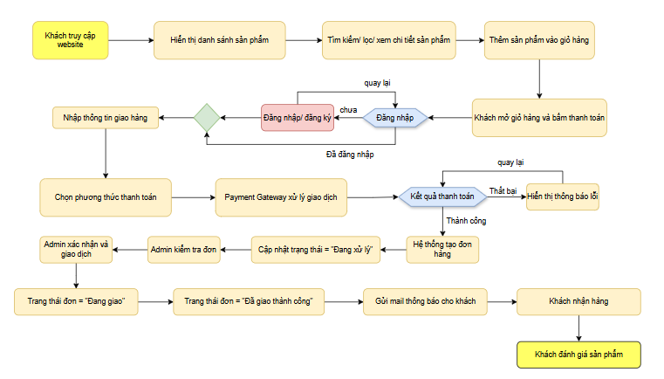

2.1.3. Conceptual model

2.1.3.1.Product Catalog
Main purpose: To manage all product information sold on the website, including computers, components, etc.
Entity | Attributes | Meaning
Product | ProductID, Name, Price, Description, ImageURL, Brand, CPU, RAM, Storage, GPU, Quantity | Product details
Category | CategoryID, CategoryName | Product categories (Laptops, PCs, Mice, Keyboards, etc.)
Relationship: Category 1 – N Product: A category can contain multiple products.
Intended test cases: View product list, view details, search/filter/paginate, Admin add, edit, delete products.

2.1.3.2.Shopping Cart
Main purpose: To save the products that customers have selected before checkout.
Entity | Attributes | Meaning
Cart | CartID, UserID | User's shopping cart
CartItem | CartItemID, CartID, ProductID, Quantity | Products and quantities in the cart

Relationship:
- User 1 – 1 Cart
- Cart 1 – N CartItem
- Product 1 – N CartItem

Intended test cases: Add product to cart, change quantity, delete product, approximate total.

2.1.3.3.Payment Process
Main purpose: To handle all payment steps and create orders.
Entity | Attributes | Meaning
Order | OrderID, UserID, TotalPrice, ShippingInfo, Status, CreatedAt | Order information
OrderItem | OrderItemID, OrderID, ProductID, Quantity, UnitPrice | Details of each product in the order
Payment | PaymentID, OrderID, Amount, Method, PaymentStatus, TransactionID | Payment transaction information
Relationship:
- Order 1 – N OrderItem
- Order 1 – 1 Payment
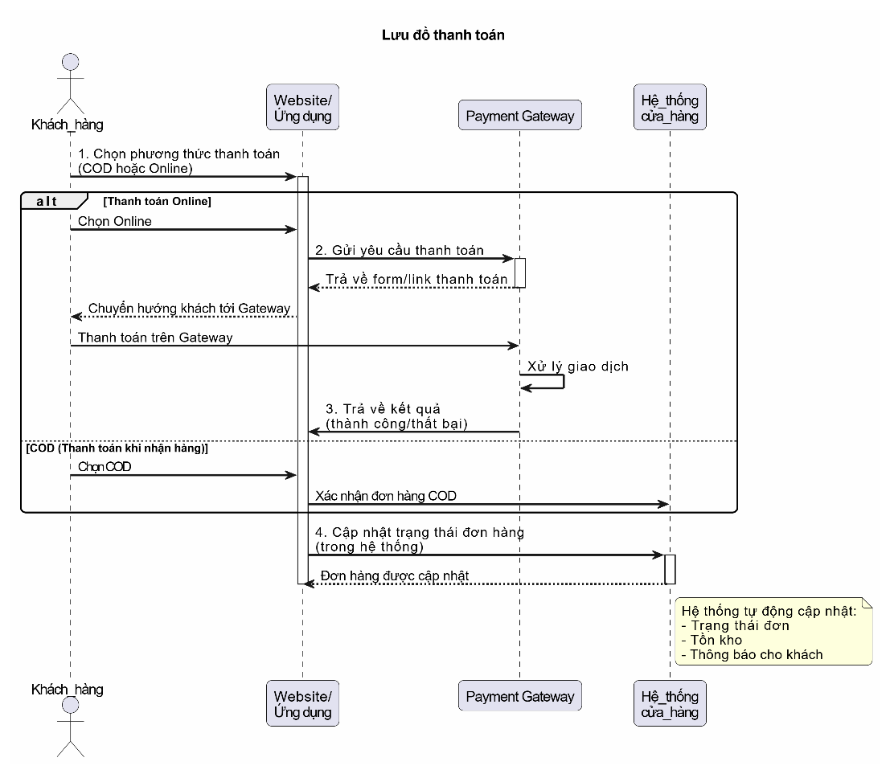

2.1.3.4.Rating
Main purpose: To allow customers to review products after purchase, helping to increase trust.
Entity | Attributes | Meaning
Rating | RatingID, UserID, ProductID, Star, Comment, CreatedAt | Customer reviews

Relationship:
- User 1 – N Rating
- Product 1 – N Rating
Proposed test case: Only customers who have purchased can leave reviews, valid reviews (1-5 stars), limit the word count of reviews, display reviews on the product page, etc.

2.1.3.5.Access Control
Main purpose: To ensure system security and differentiate access rights between clients and administrators.
Entity | Attributes
User | UserID, FullName, Email, PasswordHash, Phone, Role
Role | RoleID, RoleName (Customer/Admin)
Relationship:
- Role 1 – N User

Proposed test cases: Customers cannot access the Admin page, Admins can edit products, Passwords are encrypted/not saved as plain text, unauthorized access is blocked, etc.

2.2. General function

2.2.1. Actors in the system and their general functions

Customer:
a.Sign up/Sign in :
- Allow customers to create new accounts.
- Log in using your email and password.
- Log out of the site.
b. Browse and search for products:
- View product listings by category.
- Search for products by name, price, etc.
- Filter products by criteria.
- View product details.
c.Cart:
- Add products to the shopping cart.
- Update the product quantity.
- Remove products from the cart.
- Calculate the estimated total.
d. Place your order and make your payment.:
- Enter shipping information (address, etc.)
- Select a payment method (Cash on Delivery / Online)
- Submit a payment request to Payment Gateway.
- Receive payment confirmation upon receipt.
- The system will create the order.
e. Track your order:
- View your purchase history.
- View your order status (processing/shipping/delivered).
- Receive order confirmation notifications.
f. Product review:
- Review your order.
- Write a review for the product you are reviewing.
- Only customers who purchased the product are allowed to leave a review.
Admin
a.Product Management:
- Create new product.
- Update product’s information.
- Delete Product.
- Category management.
b.Order Management:
- View all orders.
- Update order status (Processing → In transit → Delivered).
- Cancel order if necessary.
c. Account management:
- View the customer list
d. Statistics – Reports:
- Sales statistics by day/month/year.
- Best-selling products.
- Inventory statistics.
Payment GateWay
a. Online transaction processing:
- Receive payment information from the website.
- Verify the card/e-wallet.
- Return the result (success/failure).
b. Connect to the system:

Send transaction code.

Send payment status.

Synchronize order.

2.2.2.Context Diagram
The context diagram describes the "Computer Sales Website" system as a central processing unit.
Three external actors—Customer, Admin, and Payment Gateway—interact with the system through data streams related to purchasing, management, and payment.
The diagram helps define the system's scope and the relationship between the system and its surrounding environment before proceeding to detailed design.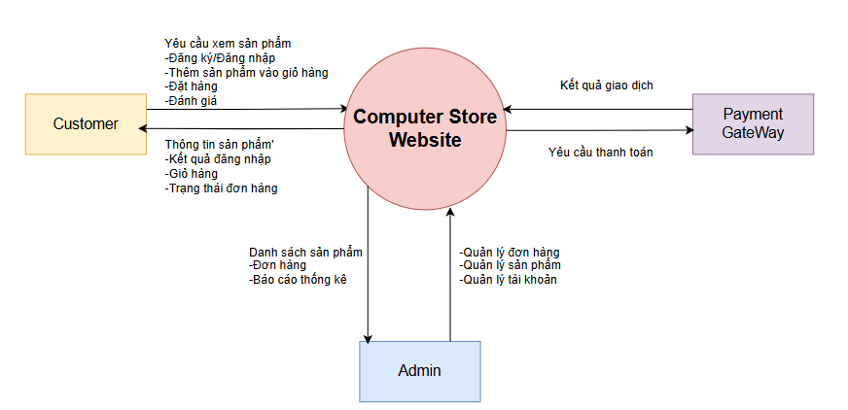

2.2.3.Use case
Customer use case:
UC Id | Use Case name
UC01 | Register an account
UC02 | System Login
UC03 | View product list
UC04 | Product Search
UC05 | View Product Details
UC06 | Add products to cart
UC07 | Update Cart
UC08 | Order Payments
UC09 | View purchase history
UC10 | Product Reviews

Admin use case:
UC Code | Tên Use Case
UC11 | Admin Login
UC12 | Product Management
UC13 | Catalog management
UC14 | User Management
UC15 | Order Management
UC16 | View statistics – reports

Use case of Payment Gateway:
UC Code | Tên Use Case
UC17 | Processing payment transactions
UC18 | Send payment results to the system
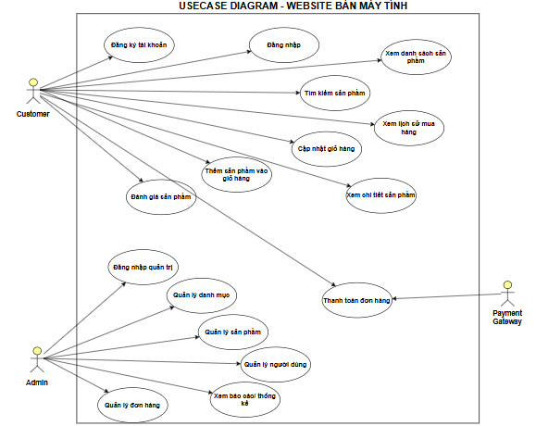
Figure 4: Usecase

2.2.4.User stories
User stories cho Customer:
Code | User Story | Acceptance Criteria
US01 | As a customer, I want to create an account to save purchase information. | Successful account creation when entering valid information; Error when the email is the same.
US02 | As a customer, I want to log in to access my shopping cart and purchase history. | Log in correctly when the information is valid; Errors when the wrong password is reported.
US03 | As a customer, I want to browse products so that I can see products by category. | Display product lists, activity pagination.
US04 | As a customer, I want to search for products so that I can find the right product for my needs. | Search returns the correct results according to the keyword or returns "not found".
US05 | As a Customer, I would like to see the product details so that I know the configuration and price. | Display photos, technical information, prices, reviews.
US06 | As a Customer, I want to add products to my shopping cart so that I can buy multiple products. | The shopping cart updates the correct quantity, not the negative quantity.
US07 | As a Customer, I want to update my shopping cart so that I can change the quantity or delete the product. | The total amount is updated by quantity.
US08 | As a customer, I want to pay so I can place an order. | The order is created successfully, the cart is empty after checkout.
US09 | As a Customer, I want to see my order history so that I can track the status of my order. | Full display of ordered orders, with status.
US10 | As a customer, I would like to review the products I have purchased so that I can give feedback. | Reviews are only allowed when the customer has made a purchase.

User stories cho Admin:
Code | User Story | Acceptance Criteria
US11 | As an Administrator, I want to log in so that I can administer the system. | Decentralize admin and user permissions.
US12 | As an Admin, I want to manage products so that I can add and delete products. | Error-free data entry form, validate price > 0.
US13 | As an Admin, I want to manage my categories so that I can organize my products more neatly. | Updated catalog, products are not orphaned.
US14 | As an Administrator, I want to manage user accounts so that I can control customers. | Lock/open an account, view the list.
US15 | As an Administrator, I want to manage orders so that I can update the delivery status. | Transfer status is correct flow: Pending → Shipping → Completed.
US16 | As an Administrator, I want to see the stats so that I can track the revenue. | The chart is displayed by day/month/year.

User stories cho Payment Gateway:
Code | User Story | Acceptance Criteria
US17 | The system wants to send a payment request to the gateway for the transaction to be processed. | The API sends the correct amount, order ID.
US18 | The system wants to receive the payment result so that I can update the order. | Success → create an application; Failure → does not create an application.

2.3. Data Design

2.3.1. Concept-level database schema

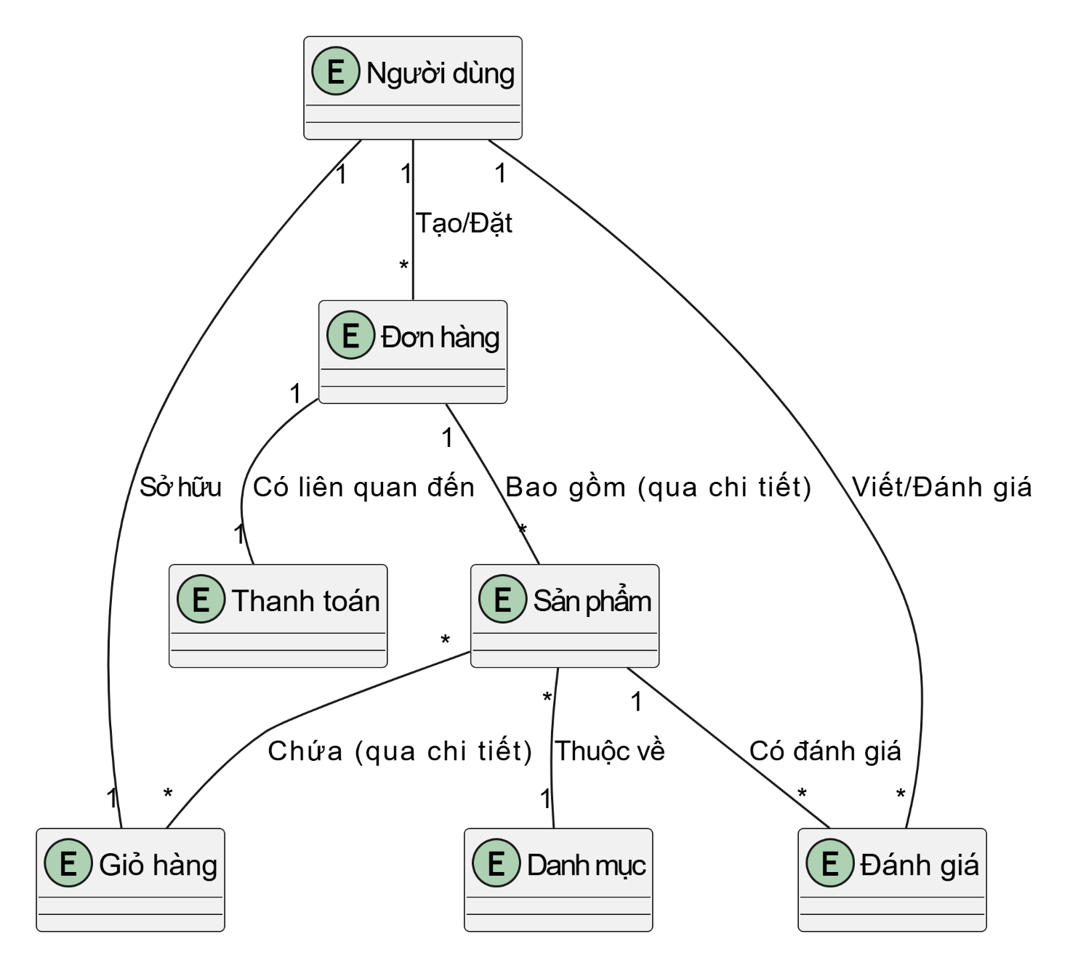
Figure 5: Schema

2.3.2. Logic-level database schema
List of tables:
- Users(UserID PK, Username, Email, Password, Role, ...)
- Categories(CategoryID PK, CategoryName, Description)
- Products(ProductID PK, CategoryID FK, ProductName, Price, Stock, ...)
- Orders(OrderID PK, UserID FK, TotalAmount, Status, ...)
- OrderDetails(DetailID PK, OrderID FK, ProductID FK, Quantity, Price)
- Cart(CartID PK, UserID FK, ProductID FK, Quantity)
- Payments(PaymentID PK, OrderID FK, Method, Status)
- Reviews(ReviewID PK, UserID FK, ProductID FK, Rating, Comment)
List of relationships:
- users and orders (1 – N): A user can have multiple orders.
- users and cart (1 – N): A user can have multiple items in the cart.
- users and reviews (1 – N): A user can write multiple reviews.
- categories and products (1 – N): A category can contain multiple products.
- products and cart (1 – N): A product can be in multiple shopping carts.
- products and order_details (1 – N): A product can be in the details of multiple orders.
- products and reviews (1 – N): A product can have multiple reviews.
- orders and order_details (1 – N): An order with multiple order items.
- orders and payments (1 – 1): An order with a payment transaction.
Primary and external key tables:
Table Name | Primary Key | Foreign Key
users | user_id
categories | category_id
products | product_id | category_id
cart | cart_id | user_id, product_id
orders | order_id | user_id
order_details | detail_id | order_id, product_id
reviews | review_id | user_id, product_id
payments | payment_id | order_id

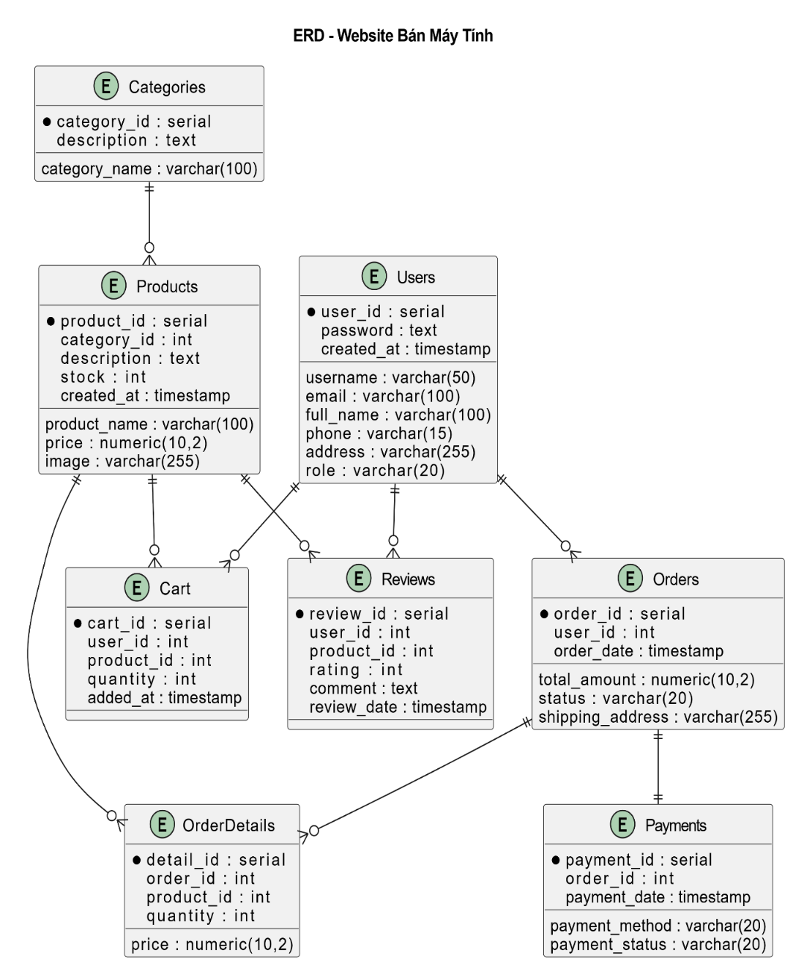
Figure 6:

2.4. System design

2.4.1. System architecture
General description:
The website system for selling computers is designed according to the multi-tier model (Three-Tier Architecture / Client-Server) including:
- Presentation Layer (Frontend): web interface for clients and admin pages.
- Application Layer (Backend/API): business processing, authentication, decentralization, ordering logic, payment.
- Data Layer (Database): lưu trữ Users, Products, Orders, Payments, Reviews, Categories, Cart.
Advantages: clear separation of responsibilities, easy to test (UI, API, DB), easy to expand (add microservices/payment gateways), easy to maintain.
Communication: Frontend ↔ Backend via HTTP/HTTPS REST API (JSON). Backend ↔ DB over SQL. Backend ↔ Payment Gateway via a third-party API.

2.4.1.1.Kiến trúc API
API design: follow RESTful principles (clear endpoints, ID-identified resources, use HTTP verbs). Each key function has its corresponding API:
- Users
  - GET /api/users/:id
  - PUT /api/users/:id
  - POST /api/ users/register — đăng ký
  - POST /api/ users/login — login
- Products / Categories
  - GET /api/products (filter, paging)
  - GET /api/products/:id
  - POST /api/products (admin)
  - GET /api/categories
- Cart
  - GET /api/cart , POST /api/cart , PUT /api/cart/:id , DELETE /api/cart/:id
- Orders
  - POST /api/orders — create an order
  - GET /api/orders/:id
  - PUT /api/orders/:id/status — admin update status
- Payments
  - POST /api/payments — transaction initiation (gateway call)
  - POST /api/payments/webhook — callback từ gateway
- Reviews
  - POST /api/products/:id/reviews — create a review
API Security:
- Dùng JWT cho authentication/authorization; token gửi qua header Authorization: Bearer <token>.
- Check the role (admin vs customer) in the middleware for the administrative endpoints.
- Binding input validation (email, quantity, price) and using rate limiting on sensitive endpoints (login, payments).

2.4.2.Domain Driven Design (DDD)
Bounded Context (suggestions):
- Catalog context: Products, Categories, Reviews — product data management, search, filtering.
- Ordering context: Cart (session), Orders, OrderDetails — create orders, manage order statuses.
- Payment context: Payments, Payment Gateway integration—transaction processing.
- User context: Users, Authentication, Authorization — account management and permissions.
- Admin context: Administrative use cases (CRUD product, report).
Layers in each context:
- API/Controllers (receive requests)
- Application Services (orchestration use cases)
- Domain Model / Entities & Value Objects (Product, Order, PaymentStatus)
- Repositories (DB communication)
- Infrastructure (ORM, external gateway clients

2.4.3. Data Models
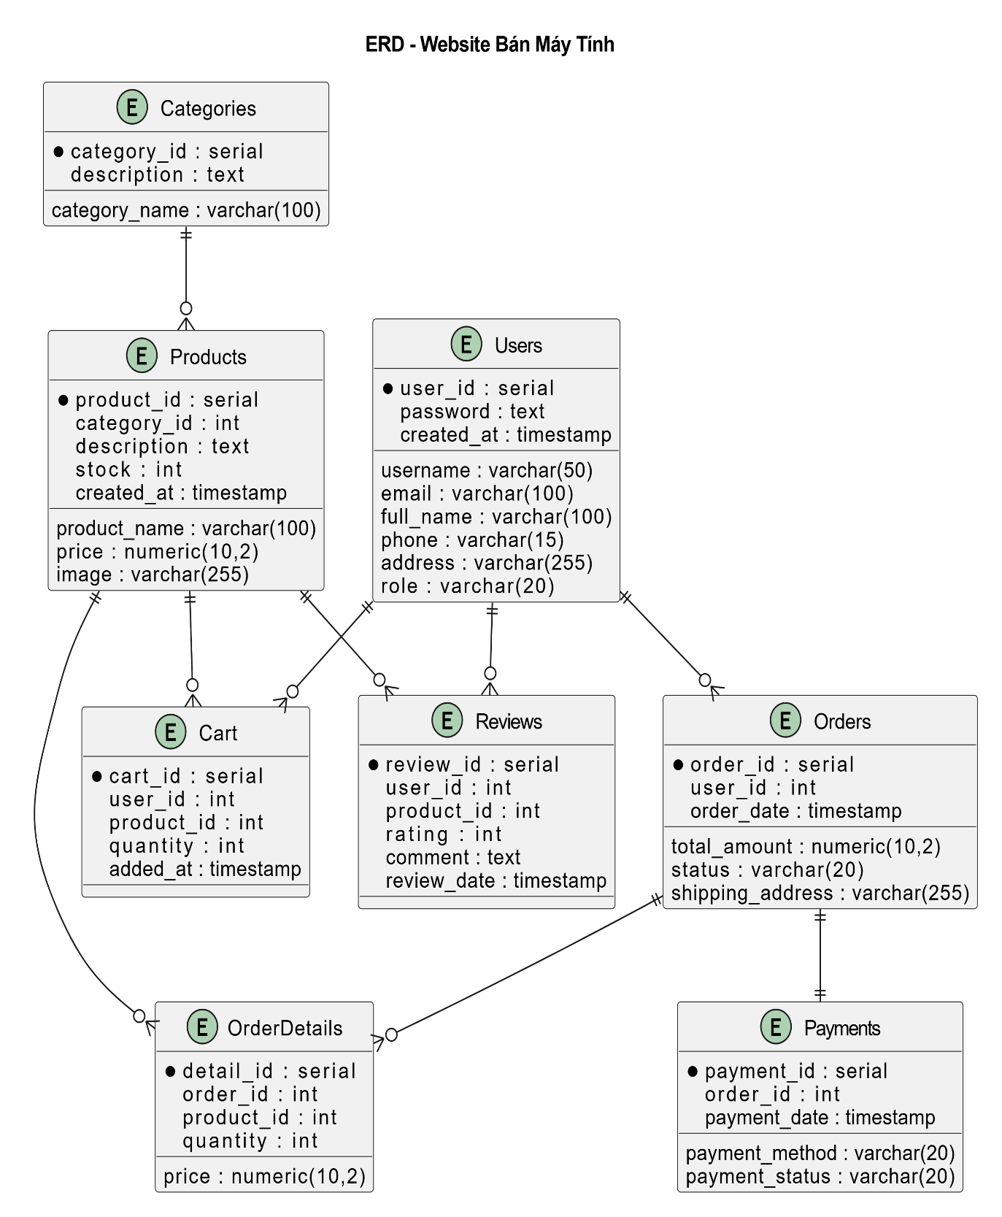
Figure 7:

2.4.4. Interface

2.4.4.1.Workflow
Figure 8:

2.4.4.2.GUI
Login:
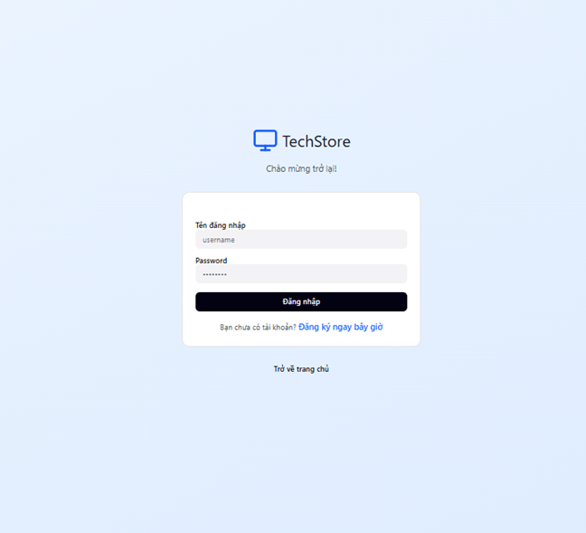
Figure 9:

Registration:
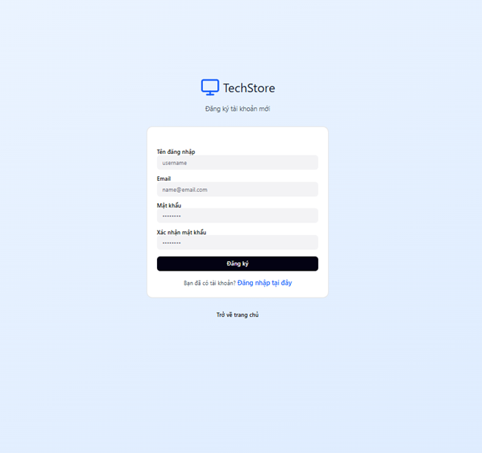
Figure 10:
Product Categories
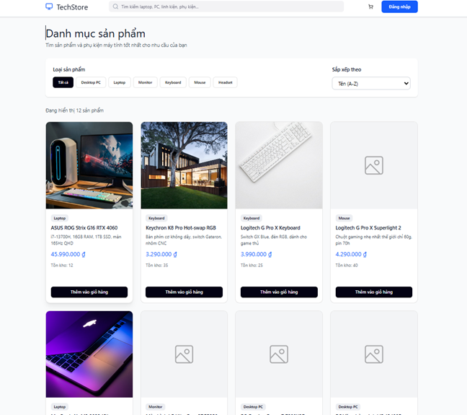
Figure 11:

Order Now
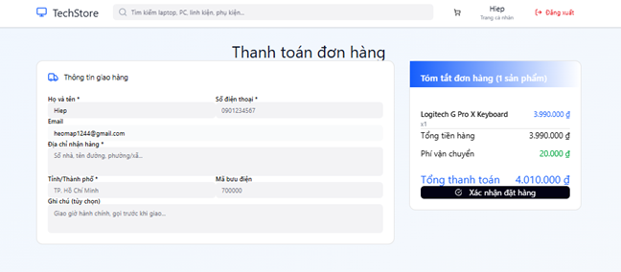
Figure 12:
Shopping Cart
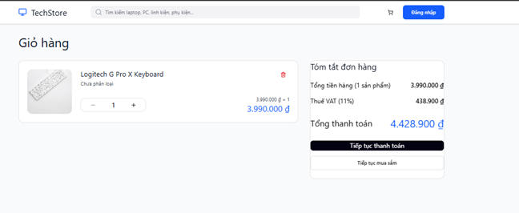
Figure 13:

Purchase History
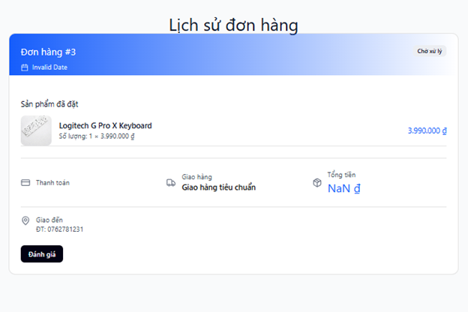
Figure 14:

Catalog management
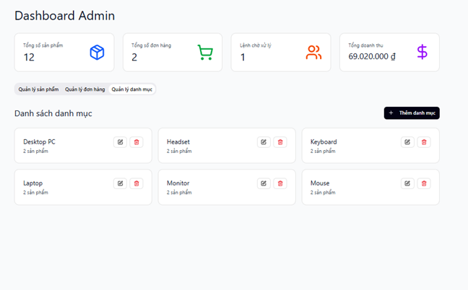
Figure 15:
Order Management
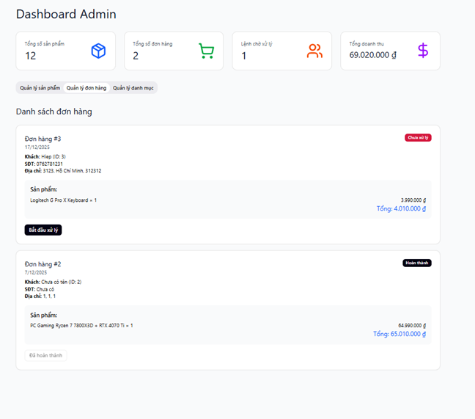
Figure 16:

Product Management
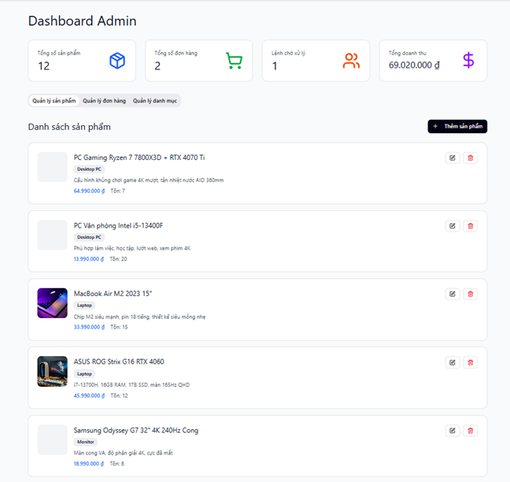
Figure 17:

Main Page
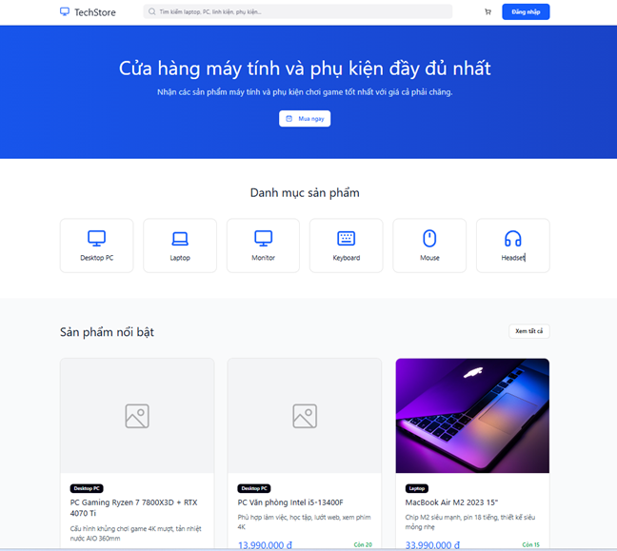

2.5. Architectural design

2.5.1. Block Diagram
The system has a frontend built using ReactJS according to the SPA model, receives requests from users and is distributed. The backend develops according to a three-layer architecture, which is separated into functional modules and communicates with the PostgreSQL database to store and retrieve data.

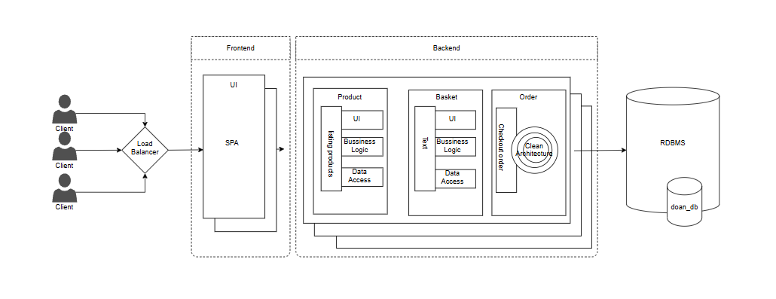

2.5.2. C4 architecture
C1 - System context
Customers use the system to log in/register, search, view details, and place orders and pay.
System administrators log in to the system to manage products, categories, orders, and payments.
The system connects to the Momo payment gateway to process transactions, receive payment results and display the payment interface to customers.
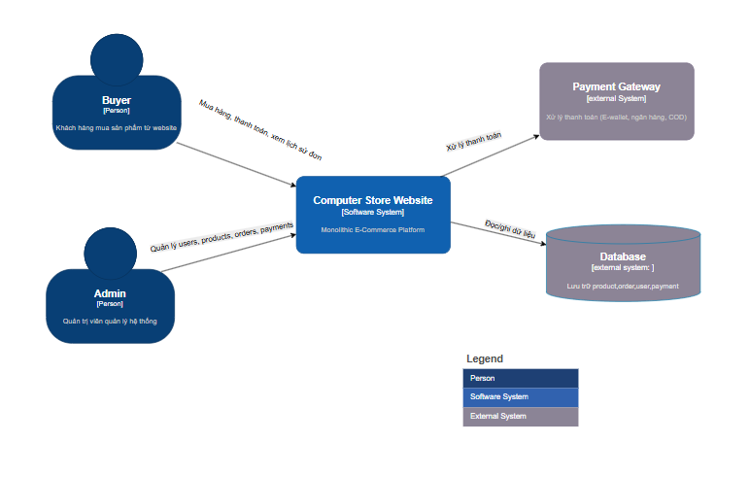Figure 2.36. C1 System Context Diagram.

C2 – Container
The ReactJS SPA container is a user interface where customers, administrators, and salespeople access it via HTTP.
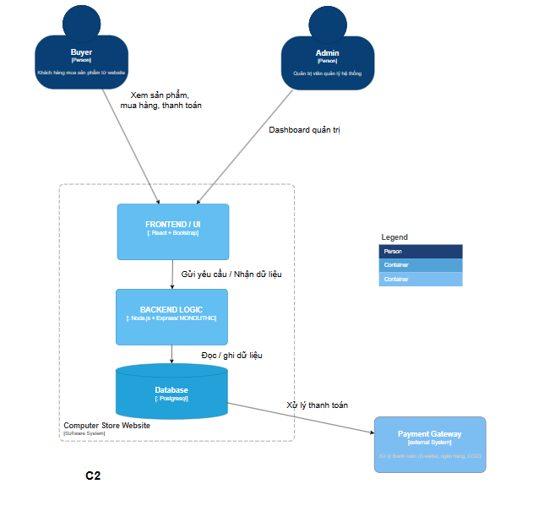
Figure 2.37. Container diagram C2.

C3 – Component (high-level)
The user interface (ReactJS) connects to the API layer. The API layer is divided into separate modules by business: Products, Carts, Orders, Payments, Categories, and Access Control.
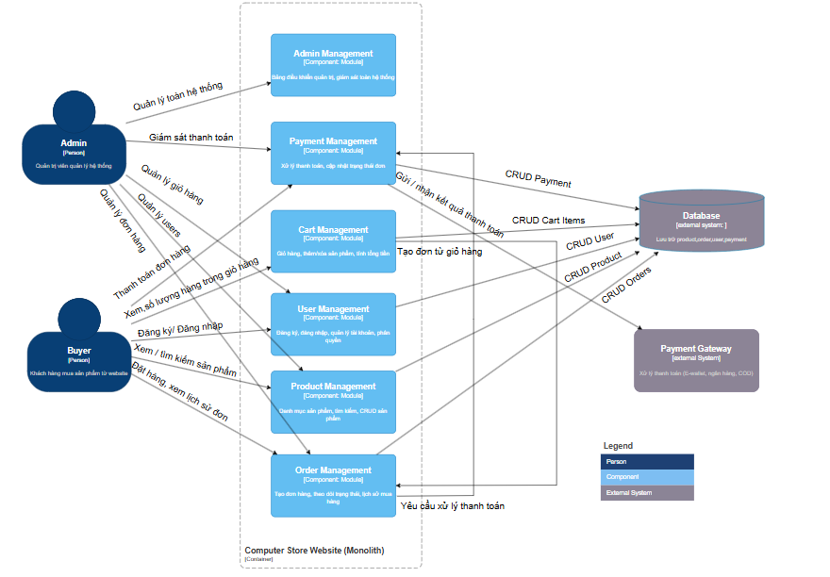Figure 2.38. C3 Component Diagram.
C4 – Code
Layer Diagram
The class number represents the Controller classes that receive requests from users, the Business Processing Service, the Data Retrieval Repository, and the Entity that represents the table in the database.
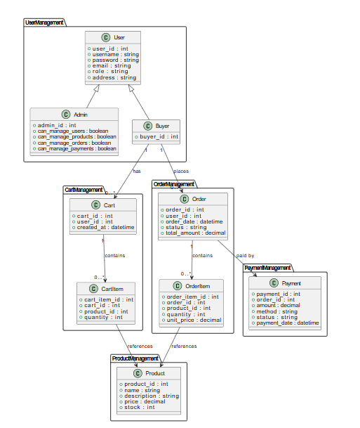
Figure 2.39. Layer Diagram

2.5.3. Implementation diagram
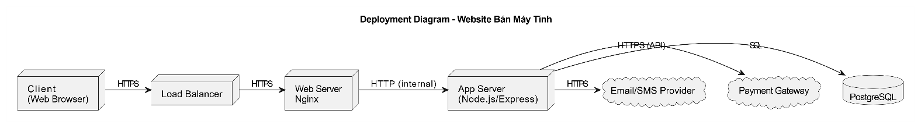

Chapter 3: Test Plan

3.1.Introduction

3.1.1. Purpose
The test plan document for the ComputerStore project was developed to identify the testing methodology, scope, and resources needed to ensure that the software fully meets the business and technical requirements. At the same time, the document helps to detect errors early, improve product quality, guide the implementation of testing in a uniform manner and control the entire testing process.

3.1.1. Scope
This test plan document describes the testing activities for the Fahasa website throughout the development and implementation lifecycle. The scope includes functional testing, unit testing, integration testing, system, and acceptance, based on the requirements in the SRS documentation, which are carried out on the planned Development and Production environments.

3.2. Items to be tested

3.2.1. Functions
Access Control
- Verify that the system allows sign-in for the customer, administrator position.
- Verify that the system allows account registration for the customer.
- Verify that the system allows sign-out for all logged-in users.
- Verify that the system enforces the correct decentralization, allowing users to access only the functions that are appropriate for their role.

Product Management
- Verify that the system provides CRUD operations for product management functionality to administrators.
- Verify that the system supports management related to the product.
- Verify that the system allows customers to access and view product listings.
- Verify that the system supports product search, filtering, and sorting functions to make it easier for customers to find the desired product.
- Verify that the system ensures the consistency and accuracy of product data between the user interface and the backend system.
Shopping cart management
- Verify that the system provides CRUD cart management functionality to the customer.
- Verify that the system automatically updates and displays the correct cart information.
- Verify that the system ensures cart data consistency throughout user manipulation and conversion between pages.
- Verify that the system has business constraints for the cart that limit the number of purchases of a product to the quantity available.
- Verify that the system allows the customer to continue the purchase process from the cart to the order step.

Order Management
- Verify that the system provides full order management to the customer, including placing orders, viewing the order list.
- Verify that the system provides full order management functionality for administrators to update order statuses.
- Verify that the system supports the correct order processing process, from order creation to completion.
- Verify that the system ensures the accuracy and consistency of order data, including order status, product information, and total amounts.
Catalog management
- Verify that the system provides the CRUD operation of the catalog management function to the administrator.
- Verify that the system supports management related to the catalog.
- Verify that the system allows the customer to access and view the catalog list.
- Verify that the system supports searching, filtering, and sorting products by category to make it easier for customers to find the products they want.
- Verify that the system ensures the consistency and accuracy of product data between the user interface and the backend system.

3.2.2. Usability
Verify that the system provides a clear navigation bar, allowing users to access key pages such as the homepage, product listings, shopping carts, and orders.
Verify that users can easily return to the previous page or homepage during use.
Verify that the main function buttons are clearly displayed and easy to operate.

3.2.3. Compatibility
Verify that the website interface is correct and consistent on popular browsers such as Chrome, Firefox, Safari.
Verify that the system automatically adjusts the interface to accommodate different screen sizes (Desktop).
Verify that the interface elements are not broken or misaligned when resizing the screen.
Verify that the user can fully operate functions on different devices.

3.2.4. Interface
Verify that the colors, fonts, and styles display correctly as designed.
Verify that logos, images, icons are displayed in the correct position and are not distorted.
Verify that error messages, warnings, or status information display correctly in the context of the business.

3.2.5. Security
Verify that the system encrypts the user password.
Verify that the access control system has the correct role and does not allow unauthorized access.
Verify that HTTP/HTTPS requests are secure, and that data is not exposed through URLs.
Verify that the system is resistant to common attacks such as SQL Injection, CSRF.
Verify that login sessions automatically expire after the specified time or when the user logs out.

3.2.6. Databases
Verify that CRUD operations on the system are properly reflected in the database.
Verify that the data is stored with the correct data format and type.
Verify that the relationships between the data tables are maintained correctly (FK, PK, binding).
Verify that search, filter, and data reporting queries return the correct results and quickly

3.2.7. Performance
Verify that the system responds quickly under normal load.
Verify that the system remains stable when there are multiple users accessing it simultaneously (load testing).
Verify that the system can withstand the maximum load without crashing (stress testing).

3.2.8. Crowds
Verify that the system is tested on a variety of devices and browsers through other tester groups.
Verify that the actual user can fully operate the functions without critical errors.
Verify that the system works stably and consistently across diverse test environments.

3.2.9. Regression
Verify that existing system functions are still working properly after the change.
Verify that endpoints, APIs, UI interfaces, databases, and business processes remain compatible and correct.
Verify that the main business flows are still running stably.

3.2.10.API
Verify that the API endpoints are functioning as designed.
Verify that the data returned from the API is accurate, complete, and follows the request format.
Verify that the access and security of the APIs are guaranteed, the user is not allowed to gain unauthorized access.
Verify that the APIs interact properly with the database, UI interface, and other related endpoints.
Verify that key business flows through the API remain stable after a system change.

3.3. Untested items

3.3.1. Functions of the Triple Test Side System
The internal processing functions of the Momo payment gateway are not included in the scope of the test.
The team only tested the integration flows between the ComputerStore system and the Momo payment gateway through the API, including sending payment requests and receiving feedback.
Ensuring the stability, performance, and internal security of the Momo system is not within the scope of the project's testing.

3.3.2. Advanced Security Testing
Penetration testing and in-depth security tests are not performed.
Security vulnerabilities at the system, infrastructure, and network levels are not covered by testing.
The team only performs security testing at a basic level, focusing on access control and user decentralization.

3.3.3. Advanced usability testing
In-depth usability testing (Usability testing with real users, UX surveys) is not performed.
Evaluating user sentiment, satisfaction, or behavior is not within the scope of testing.
The team only performs a basic level of usability testing to verify that the system is operable and usable.

3.4. Criteria for acceptance testing

3.4.1. Test coverage
At least 95% of the system's functional requirements must be designed and executed test cases.
All important use cases must be tested.

3.4.2. Percentage of test cases passed
100% of Critical and Major test cases must reach Pass status.
The total rate of test cases must reach ≥ 98%.

3.4.3. Number of Test Cases
All test cases at the following levels must be executed:
- Unit Test.
- Integration Test.
- System Test.

3.4.4. Number of errors
Critical level errors should not exist at the time of acceptance.
The number of Major level errors must not exceed 2 errors and there must be an agreed solution.
Minor level errors do not affect the main functionality of the system.

3.4.5. Unit Test Density
The test unit density must reach a minimum of 80 Unit Test Cases per 1000 lines of source code (80 UTC/KLOC).

3.4.6. Source code coverage
The indicators of source code coverage must be achieved:
- Statement Coverage ≥ 90%.
- Branch Coverage = 100%.
- Path Coverage = 100%.

3.4.7. CI/CD process
The GitHub Actions CI/CD pipeline must run successfully with a successful status.
There should not be any test errors in the automated pipeline.

3.5. Testing strategy

3.5.1. Testing methods
The project applies the V-Model model in software testing, in which testing activities are carried out in parallel with the development stages. Each stage of development corresponds to a level of testing to ensure the quality of the software throughout the development lifecycle.
Specifically, the project implements testing levels including: unit testing, integration testing, system testing and acceptance testing. Test Cases are designed based on the functional requirements and use cases of the system.
In addition, the project applies automated testing through a CI/CD process using GitHub Actions, to automate the Build, Test, and Deploy steps.

3.5.2. Type of test
Type of Test | Purpose | Technique | Acceptance Criteria
Functional Testing | Ensure that the business functions of the system work in accordance with the required specification | Manual Test Case Design  Automate Test System Function Testing with Selenium | All Test Cases function pass (Pass) and there are no critical faults or blocks
Check the interface | Ensure the UI displays the correct layout, content, actions, and responses as users interact | Selenium Basic Test on a Few Pages  Manual testing across browsers and devices | The interface displays the right layout on all screens of devices and browsers
Compatibility testing | Make sure your website works stably on different browsers and devices | Manual testing across browsers and devices | The system works and displays stably on all set platforms
Security Testing | Detect obvious vulnerabilities such as unauthorized access, wrong decentralization, input security errors | Decentralized testing, validation, and input testing in integration test | No detection of common security vulnerabilities, no unauthorized access
Performance testing | Ensures fast response system, stable simultaneous processing, and high load resistance | Load testing, Stress testing bằng K6 | Response time ≤ predetermined limits; the system withstands the maximum load without crashing; No serious faults occur under high loads
Crowd testing | Detect bugs, compatibility issues, and real-world user experience through other teams of testers | Manual testing across multiple devices and browsers, gathering real-world feedback | The user can practically operate the full range of functions without serious errors; The system operates stably and consistently in diverse environments
Usability testing | Evaluate user experience, ease of use, navigation, and operation | Manual testing by other tester teams | Users can operate easily, precisely and comfortably when using the system
Regression Testing | Ensure that functions that have been working stably are not affected after updating, fixing bugs, or adding new features | Automation that combines CI/CD and Selenium | The pass rate of regression Test Cases must reach at least 98%; GitHub Actions test run successfully completed
API Testing | Evaluate the accuracy and stability of APIs in terms of returned data, code status, request validity, and response | Using the Postman tool | Accurate status code, valid and accurate returned data

3.5.3. Test level
Level | Purpose | Technique | Method
Unit Testing | Check the correctness of functions/methods | White Box | Automated testing in a development environment
Integration testing | Check the interaction between functional modules | White Box | Automated testing in the Development environment
System Testing | Test business flows and interfaces | Black Box | Automated testing with Selenium (UI, E2E) and K6 (performance) in a Development environment
Acceptance testing | Product Inspection and Acceptance | Black Box | Manual testing in the Production environment

Type | Test Level
Type | Unit Testing | Integration testing | System Testing | Acceptance testing
Functional Testing | x | x | x | x
Check the interface |  |  | x | x
Database testing | x | x
Compatibility testing |  |  | x | x
Security Testing | x | x | x
Performance testing |  |  | x
Usability testing |  |  | x | x
Crowd testing |  |  | x | x
Regression Testing | x | x | x
API Testing | x | x

3.6. Resources

3.6.1. Human resources
Performer | Role | Specific Jobs
Huynh Le Hoang Tuan | Tester/Programmer | Plan tests, perform system tests, write CI/CD code in GitHub Actions, document test assets  Test Case Design, Unit Testing and Integration Testing, Checklist Review, Test Documentation Recording

3.7. Environment

3.7.1. Hardware
Item | Ingredients | Purpose
Development | Personal Computers | Programming, running unit tests and integration tests
Equipment | Desktop | Interface testing and compatibility testing

3.7.2. Software
Item | Ingredients | Purpose
Development | VSCode,ReactJS, Local PostgreSQL | Programming, running unit tests and integration tests
Browser | Chrome, Firefox, Safari | Interface testing and compatibility testing

3.7.3. Infrastructure
Item | Ingredients | Purpose
Production | Frontend and Backend deploy on Render | Actual software deployment, system testing and acceptance
CI/CD | GitHub Actions | Automate the Build, Test, and Deploy process

3.8. Documents handed over
Word documentation includes Architecture Design, Database Design, Test Plan, Software Requirements Specification, Bug Report, and overall software and testing reports.
Prepare excel documentation including documentation of all interfaces, specifications of Use Cases, Review Checklist, Test Report, Test Case, Test Design.
The project's source code is stored on GitHub including unit tests, integration tests, and system tests, and CI/CD pipelines on GitHub Actions (.github/workflows/ci-cd.yml).

Chapter 4. Test design

4.1.Introduction
This chapter presents the process and results of designing detailed test cases based on the V-Model strategy.

4.2. Design and testing process according to V-model
The team's test design process is built entirely on the V-Model model – a model that emphasizes symmetry and reciprocity between development and testing.
In a V-shaped structure, each phase of analysis and design in the left branch has a corresponding test activity on the right branch, to ensure that every requirement can be verified through a specific test case.

4.2.1.Requirements Analysis – 1a
In the first stage, the team collects, analyzes and clarifies the business requirements of the online paper book sales system. The goal of this step is to ensure all requirements are fully described, scoped, and testable. The team develops the Software Requirements Specification (SRS) document as the basis for all subsequent testing activities.
From the analysis process, the team determined that the system has two main user objects (Customers and Administrators) and decays into 5 functional modules: Product Management, Shopping Cart, Orders, Categories, Access Control.
The results of requirements analysis are the direct foundation for building acceptance test cases. Requirements are translated into acceptance criteria, ensuring that any functionality expected by users can be verified through testing.

4.2.2. System design – 2a
Once the requirements have been clearly defined, the team proceeds to design the system at the overall level. The design includes a description of key functions, business flows, use case diagrams, and relationships between actors interacting with the system.
The information from this stage is used to build the system test scenario. The functions described in the use case diagram will become the object of testing, ensuring that the system operates correctly according to the overall business flow.

4.2.3. Architectural design – 3a
In the architectural design phase, the team applies the C4 Model (Context – Container – Component – Code) architecture to decompose the system from the context level to the component level. The aim is to clearly define the communication between layers, the separation of responsibilities, and the flow of data between components in the overall architecture.
The architectural design results are the basis for building integrated testing. The points of communication between the modules – such as between the API and the database, between the backend and the frontend – are listed and analyzed to design test cases to evaluate the accuracy of data exchange between components.

4.2.4. Module design – 4a
In the module design step, the team analyzes and designs each module of the system. Class diagrams are used to describe data structures, properties, methods, and relationships between classes.
The material from this step is used to build unit test cases. The key classes and methods of each module are defined for automated test writing, which helps to detect errors at the lowest level before the module is integrated into the system.

4.2.5. Unit Testing – 1b
Based on the modular design, the team builds and executes unit test cases to evaluate the correctness of each independent method, function, or class.
The goal of unit testing is to ensure that each of the smallest components works exactly as described in the design, thereby minimizing the risk of defects spreading to the integration and deployment stages.
Unit test cases are deployed to automatically test dependencies, helping to separate the test logic from external components such as databases or other services.
All unit tests are integrated into the CI/CD environment through GitHub Actions, allowing tests to run automatically every time the source code is updated. This helps the team detect bugs early, stabilizing the quality of the software throughout the development process.

4.2.6. Integration Testing – 2b
After each module has stabilized through unit testing, the team conducts integration testing to evaluate the interaction between components in the system. Integration testing focuses on verifying data transmitted through APIs, Controller-Model-Route communication layers, as well as compatibility between the backend and the database.
The team uses Postman to test API integrations in a near-realistically simulated environment. Postman allows you to send requests, receive responses, and check the entire processing flow without running the actual application on the server.
Integrated test cases are designed based on the communication points identified during the Architecture Design phase, ensuring that the testing process adheres to the correct system structure and covers all critical interaction flows.

4.2.7. System Testing – 3b
At a higher level, the team conducts system testing to evaluate the entire operation of the software as a whole. System testing is carried out in a manual approach based on the set of Test Cases that have been built at the test design stage, covering a full range of scenarios according to the use case and the user's main business flow.
Testing activities include:
- Functional testing: check end-to-end business flows such as login, purchase, payment, etc.
- Interface testing: ensure the interface is intuitive, consistent, and meets display standards.
- Basic security testing: verification of login flow, decentralization, and access control.
The results of the system test reflect the overall quality of the software before moving on to the acceptance phase.

4.2.8. Acceptance Testing – 4b
Acceptance testing is the final stage of the testing process, which aims to evaluate the system from the perspective of actual users. In this step, the team compares the acceptance criteria with the SRS document to ensure that the system fully meets the customer's requirements.
After completing the internal system test, the software is handed over to the Product Owner for acceptance testing. The Product Owner will act as an end-user, simulating real-life situations and making an assessment of the level of demand response, convenience, stability, and business suitability.
Acceptance test results are an important basis for making a final decision on deploying the system to the operating environment.

4.3. Design and test techniques

4.3.1. Black box testing
Black box testing is used to test the functionality of the system based on business requirements, without regard to the internal structure of the software.
In the project, this method applies to system testing and acceptance testing, as the goal is to verify that the software works as expected by the end user and meets the acceptance criteria.
The use of black boxes helps teams simulate real-world scenarios and test the entire business flow from start to finish, suitable for manual execution or automation at the interface level.
For example: For AccessControl test cases, the team uses equivalent partitioning, state switching, decision tables, and use case techniques.
Equivalent Partitioning:
In the Access Control test case, the input data is divided into valid and invalid classes based on the account status and validity of the user information. Specifically:
For the login function:
The class is valid when the username and password are correct, the account is active
Invalid class when the password is wrong and fails to log in
For the function of registering/adding users:
The class is valid when the Email is new, full of required information
The class is invalid when the Email already exists and the required field (email) is blank
State Transfer Technique:
In the Access Control module, important statuses include:
- Session statuses include logged in and logged out.
Test cases are built to test: The transition from logged in → logged out. Verify the system behavior after the state changes.

4.3.2.White Box Testing
White-box testing is used to test the logic inside code, data streams, conditional branches, and loops, helping to detect errors at the individual module or method level.
In the project, this method applies to unit testing and integration testing, as the goal is to ensure that each component works exactly as designed and that the modules interact correctly.
The use of white boxes helps the team detect errors early, reduce integration risks, and facilitate automated testing.

4.4. Testing methods

4.4.1. Manual testing
The project applies manual testing to the acceptance testing phase. This method is used to evaluate the system from the perspective of the end-user, examine key business flows, and confirm how responsive the system is against the specified requirements.
Manual tests are carried out based on the designed Test Case and Review Checklist, the test results are recorded and compared with the expected results before conducting the system acceptance.

4.4.2. Automated testing
The project applies automated testing through the integration of the CI/CD process using GitHub Actions to automate the process of building, testing, and deploying the system. Automated testing is used for white-box tests including unit testing and integration testing and system testing.
Every time a source code change is pushed to the GitHub repository, the CI/CD pipeline automatically activates the test job.
- If the job test fails, the pipeline will automatically create an issue on GitHub to record the bug that arises, supporting the development team to track and handle it in a timely manner.
- If the job test is successful, the pipeline will automatically close issues related to previous test errors, ensuring that the system status is always updated accurately.
When the source code is merged into the main branch, the CI/CD pipeline will activate the job deployment, making a call to the Render platform to redeploy the system.

Chapter 5. Test Report

5.1.Overview of the testing process
After completing the test design phase in Chapter 4, the team carried out testing for the ComputerStore system according to the set plan. The testing process is implemented in 6 weeks including phases from unit testing, integration testing, system testing, and acceptance testing.
The team focuses on testing all of the system's key business capabilities. Test Cases are carried out carefully, in detail and the results are fully documented in the handover documents.

5.2. Test case reports

5.2.1. Introduction
These test cases are categorized into two groups: Positive (testing behavior in line with system expectations) and Negative (testing the ability to handle errors, exceptions, and invalid conditions).
The test suite is built for 5 main functional modules of the system including access control, product, cart, order, catalog, with a total of 34 test cases.
Module | Code | Quantity | Description | Results
Access Control | AC | 6 | Check the login and registration processes | 5 Pass  1 Fail
Products | PM | 8 | Check visibility, search, filter products for customers  Check add, edit, delete actions for administrators | 8 Pass  0 Fail
Shopping Cart | CM | 12 | Check for add, edit, delete, and check existing quantities when adding products to cart | 12 Pass  0 Fail
Orders | OM | 5 | Check the customer's ordering process  Check your admin's order status management and updates | 5 Pass  0 Fail
Categories | CAM | 3 | Check add, edit, delete actions for administrators | 3 Pass  0 Fail

5.2.2. Coverage
The team has built 34 Test Cases that cover 100% of the system's key functions. The coverage of non-functions is 0%.

\

5.2.3. Execution Results
The pie chart shows the execution percentage of all Test Cases.
A total of 34 Test Cases, of which 33 were successful and 1 failed.
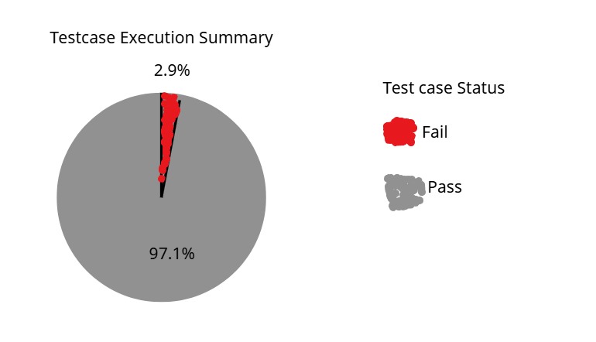

5.3.Bug reporting

5.3.1. Classification of faults by severity
During the Test Case test, the team detected and recorded 1 bug. These bugs are classified by severity as follows:
Severity 4 – Low: there is 1 bug, this is a minor, interface-related bug that causes the behavior to not interact with the order function module.

5.3.2. Error statistics
The column graph shows the number of Test Case defects by severity.
A total of 1 bug was detected, in which:
- 100% is 1 low error.
- 0 medium errors.
- 0 critical and high errors.
The number of bugs that have been fixed has fixed 1 medium bug and 1 low-level bug.
The number of outstanding errors is 0 errors at any level.

5.3.3. Error handling process
The error handling process is carried out according to standard procedures, ensuring that any detected errors are recorded, classified, and handled in a timely manner in the project. The specific steps are as follows:
Step 1: Record the error
When performing testing, every defect detected is recorded including: fault description, related module, Test Case/Test Script, severity, bug detector, and when it was detected.
Step 2: Classify errors
The test team classifies the bug by severity:
Classification helps the development team prioritize handling errors according to their importance.
Step 3: Assign error handling
The bug is escalated to the developer or development team in charge of the relevant module. Each error is assigned a status (Assigned) and the person responsible for handling it.
Step 4: Fix the error
The development team works to fix the bug according to the identified cause:
- Data errors: editing the processing logic or checking the input data.
- Interface bugs: interface adjustments, missing functions.
- Bugs in CI/CD: fix class names, fix code in Spotless format.
Step 5: Retest
After the bug is fixed, the test team conducts a retest to confirm that the bug has been fixed. If the error persists, go back to step 3 to fix it further.
Step 6: Close the error
Errors are marked Closed when:
- The bug has been thoroughly fixed and retested successfully.
- No longer affects other system functions.
All closed errors are noted in the summary report.
Step 7: Report and track bugs
The test team aggregates the number of bugs by severity, processing status, and associated Test Case/Test Script.
This report is used to evaluate the quality of the software and improve the testing process in the next stages.

